**Ben Ghirardani PDA**

**Unit Implementation & Testing**

I & T 5 - Demonstrate the use of an array in a program

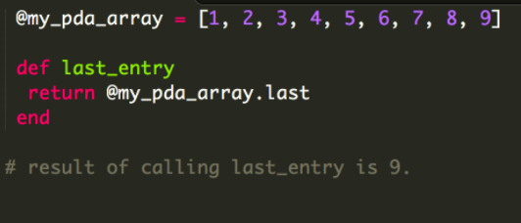

I & T 6 - Demonstrate the use of a hash in a program

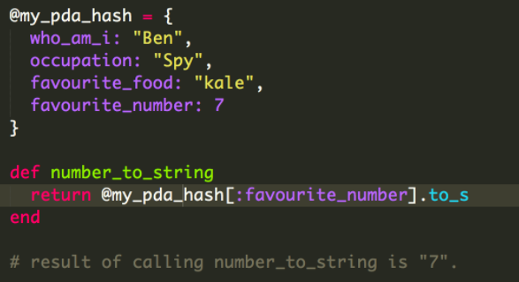

I & T 3 - Demonstrate searching data in a program

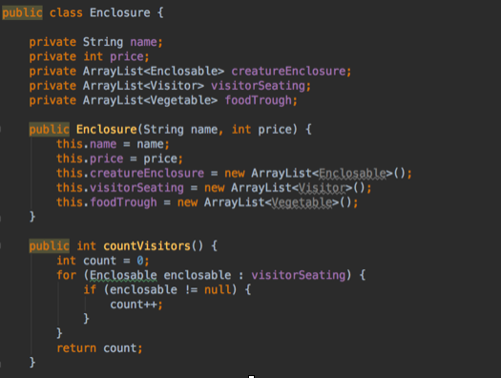

The result of this method is 0 as there has not yet been anything added to the empty arraylist.

I & T 4 - Demonstrate sorting data in a program

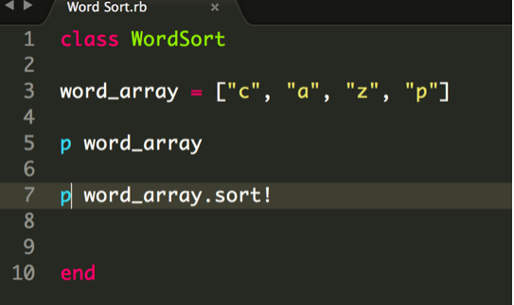

The result of word_array.sort! Is : ["a", "c", "p", "z"]

I & T 7 - Demonstrate the use of Polymorphism in a program

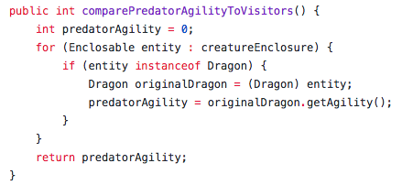

The code above shows an instance of the class Dragon which extends the abstract class Creature, which in turn implements the interface Enclosable. The arraylist creatureEnclosure is populated by instances of the Enclosable interface. The code uses polymorphism to cast the Enclosable object back into an instance of the class Dragon.

I & T 1 - Take a screenshot of an example of encapsulation

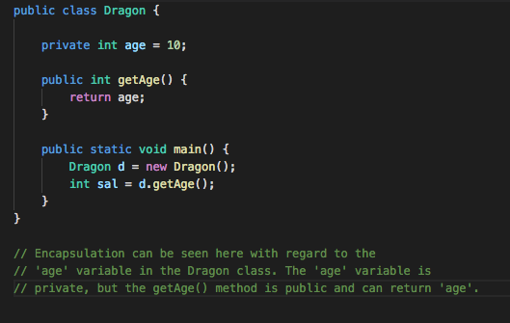

I & T 2 - Take a screenshot of the use of inheritance in a program

Take screenshots of:

A Class:

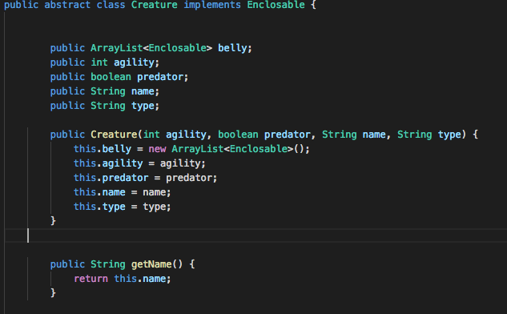

A Class that inherits from the previous class:

An object in the inherited class:

A method that that uses the information inherited from another class:

